Risk landscape Layout Evolve 2.3

|  |  |  |
| --- | --- | --- |
| Auteur | Date | Version |
| Luting HONG | 2015/06/12 | 1 |

**Please note that this layout is designed only for Evolve 2.3**

Sommaire

2 What’s risk landscape in Evolve? 3

3 How to install it? 3

4 Meta model configuration 4

5 How to configure the layout in Evolve Designer 5

6 Change table cell’s colors 6

# What’s risk landscape in Evolve?

Risk landscape layout allows to display a list of objects in a matrix, which is based on the value of 2 properties of these objects. In our example, the vertical axe “**Impact**” and the horizontal axe “***Probabilité***” are two drop down list properties of the “***Risque***” object type.

The colours have different meanings in the matrix.

* Green stands small impact, small possibility of a risk
* Yellow stands medium impact, medium possibility of a risk
* Red stands big impact and big possibility of a risk.

**Attention: To have the same looking feel (ex, colour location), please follow the instruction of Meta model configuration.**

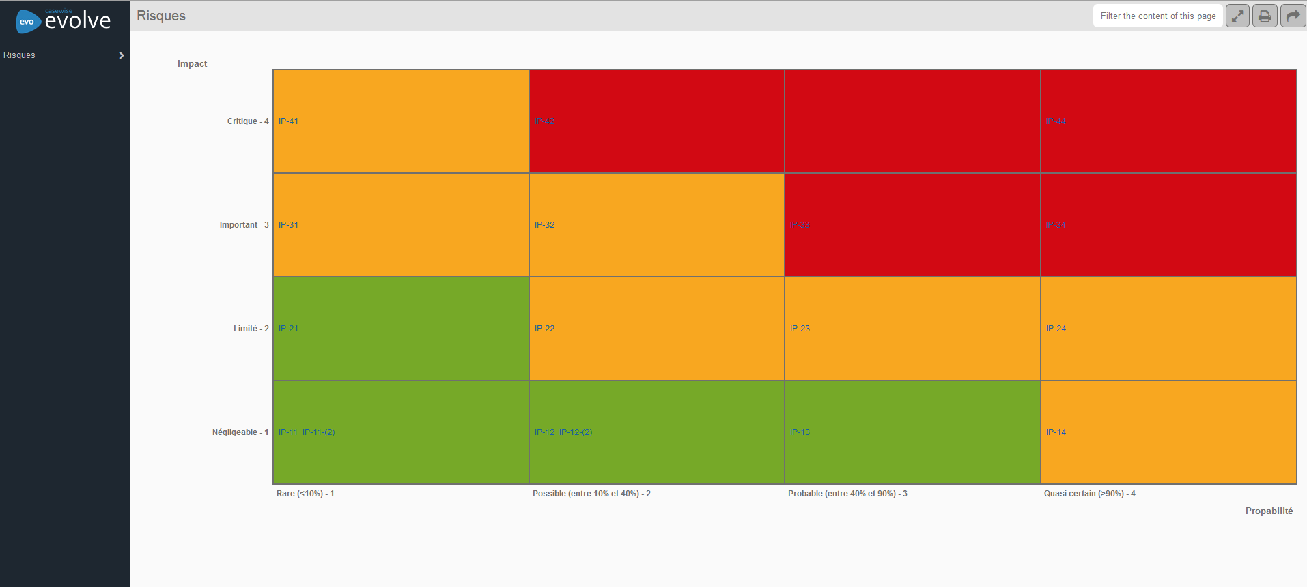

# How to install it?

The installation of a custom layout requires only to put the custom files at the right folder.

C:\Casewise\Evolve\Site\bin\webDesigner\custom\YourCustomFolder\libs\cwLayouts

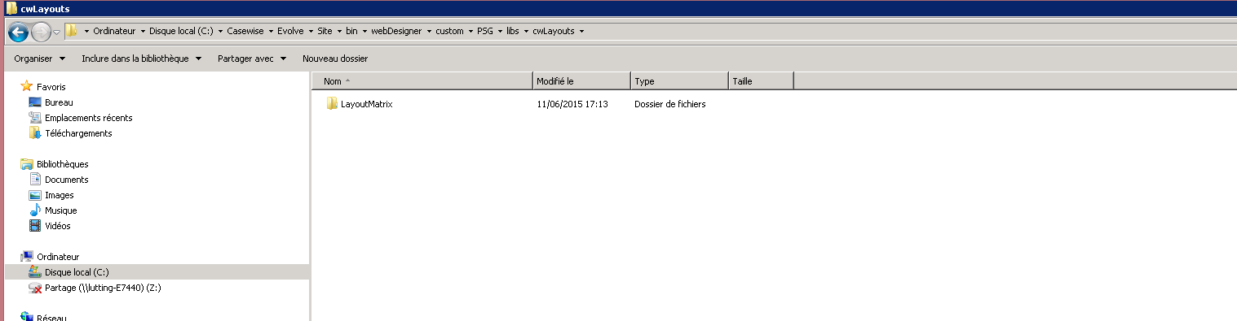

# Meta model configuration

1. Create an object type for Risk ( ex. **Risque**)
2. Create 2 properties type of Risk, for example
   1. **Impact (**Script name**:impact)** Data type: **Drop down list**
   2. **Probabilité** (Script Name : **probabilité**) Data type: **Drop down list**
3. Edit properties look up value, make sure that each value has an abbreviation
   1. **Impact** (ex => ***1: Négligeable; 2:Limité;3:Important;4:Critique)***

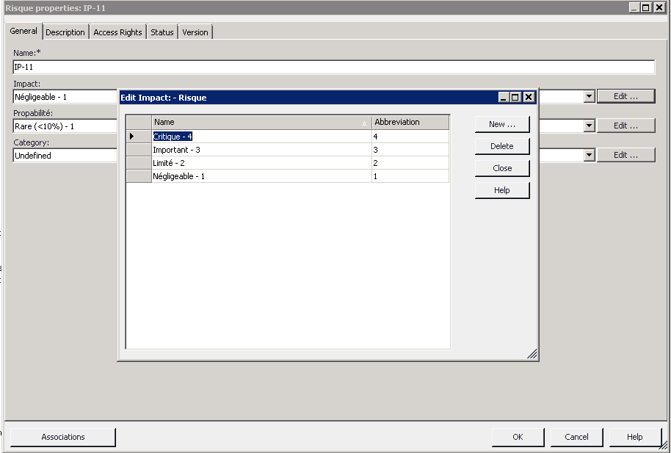

* 1. **Probabilité** (*Ex=>* ***1 : Rare ; 2 : Possible ; 3 : Probable ; 4 : Quasi certain)***

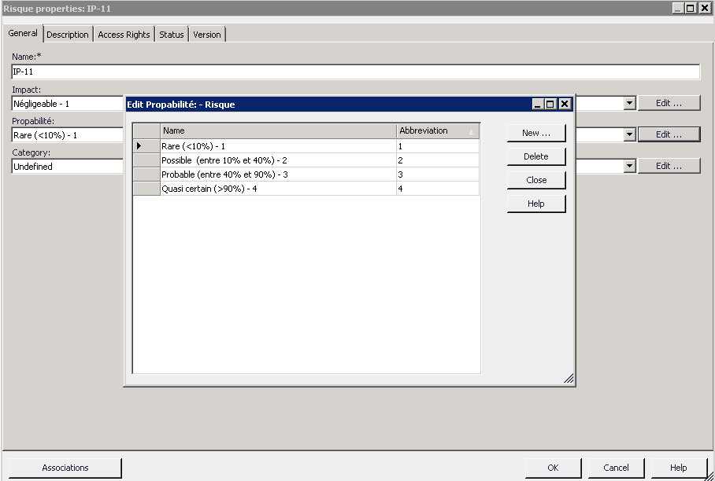

# How to configure the layout in Evolve Designer

1. Create an index page, and check properties “**Impact**” and “**Probabilité**” in “Selected Properties”.

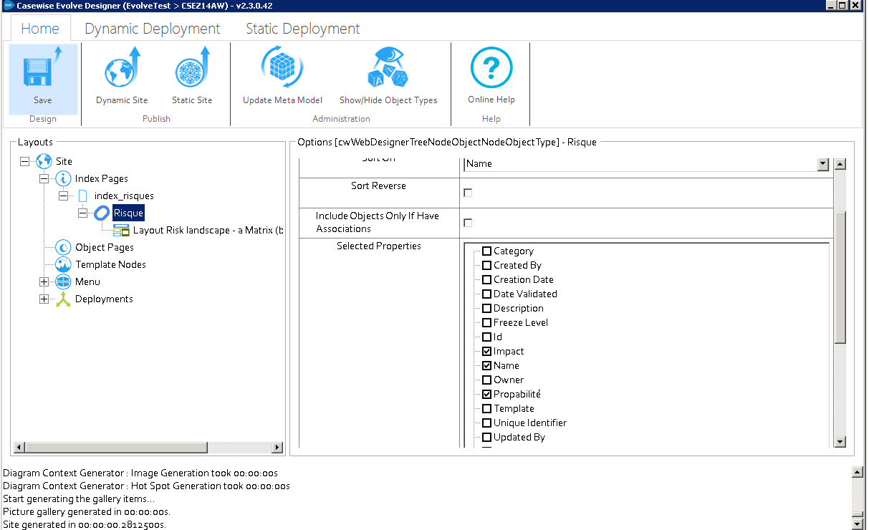

1. Switch layout to “Layout Risk Landscape”

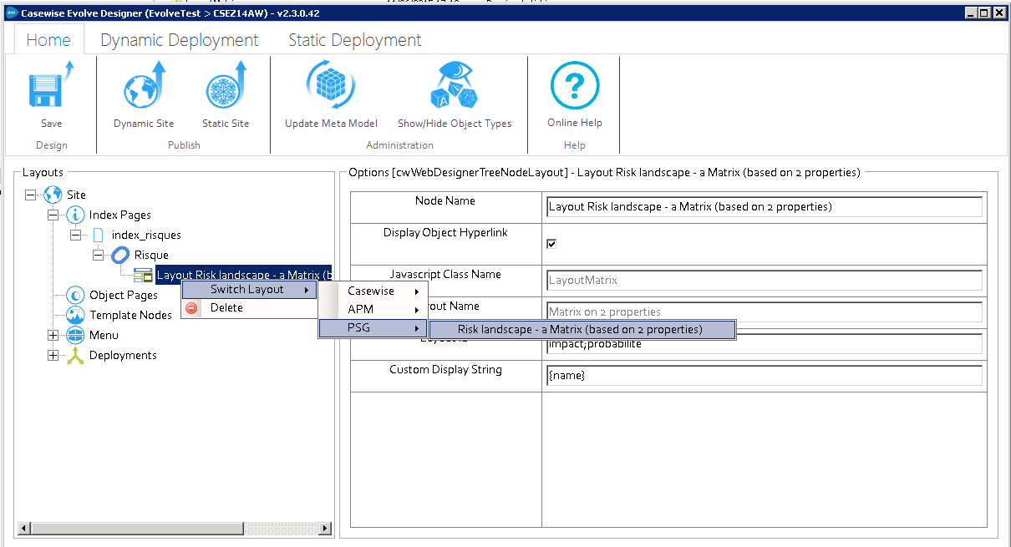

1. In the field of “Layout ID”, fill the script name of “*Impact*” and “*Probabilité*” separated by “**;**”.

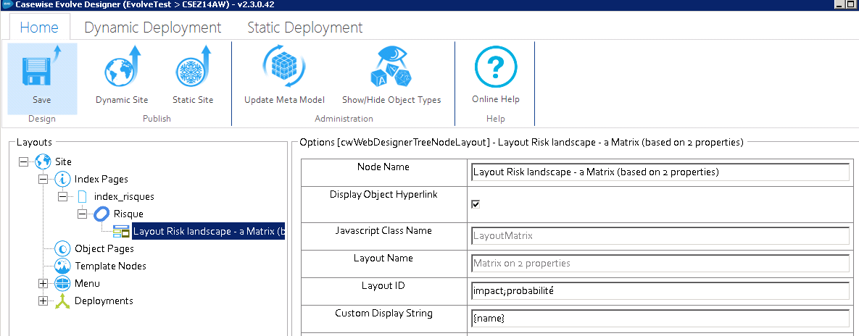

# Change table cell’s colors

The default matrix is a 4x4 table, green, yellow, red colors are hard coded in a css file.

If you want to change colors, or you matrix is not a 4x4, but a 4x5; please edit the css file.

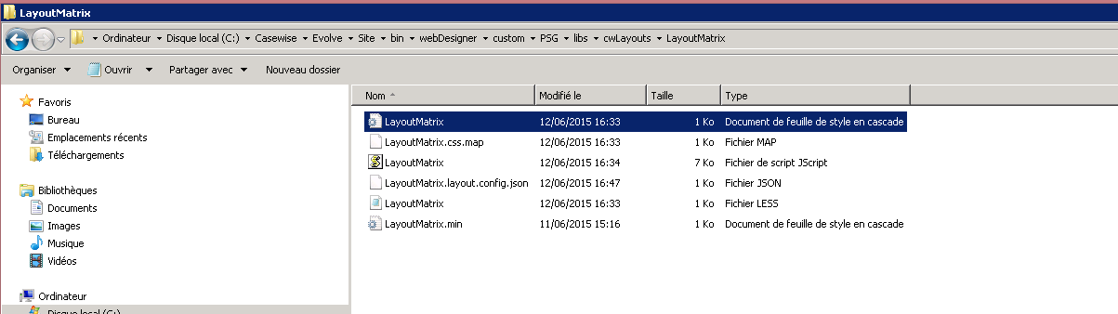

Example: The class name of each cell is like ***r_1_c_1***

***r*** is for row and ***c*** for column, the number is the value of abbreviation value.  
That means, the **impact** value is ***1***, and **probabilité** value is aussi ***1***.

